**COMPUTER NETWORKS**

**NAME: M.ISTAFA MALIK**

**ROLL: P190033**

**SECTION: BSCS-5A**

**Task: Implement the S-NAT for web servers of (flex and slate) in a single topology.**

**Step 1: Topology**

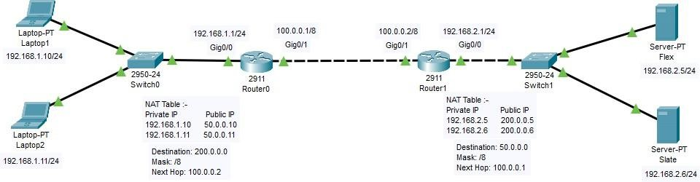

**Step 2: PC Configuration**

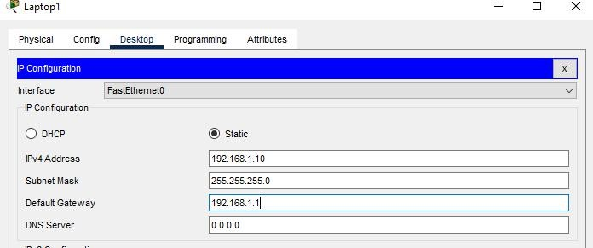

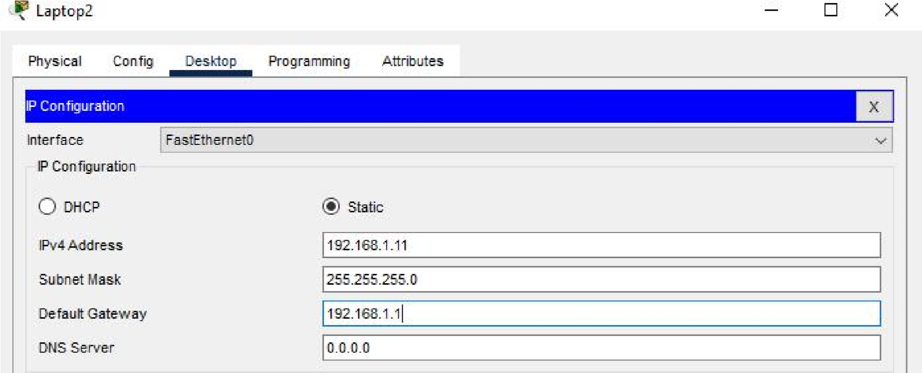

**Step 3: Server Configurations**

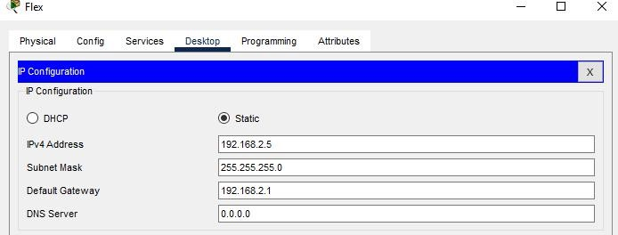

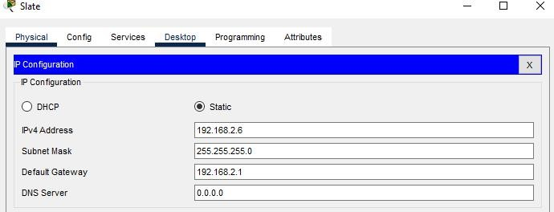

**Step 4: Router Configurations**

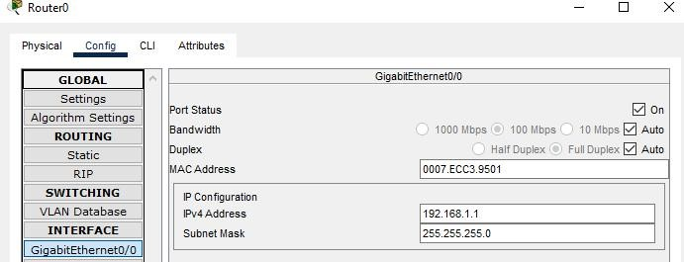

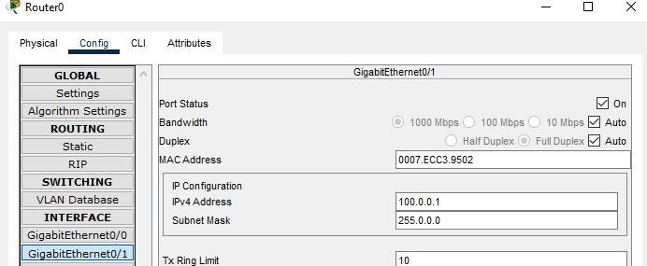

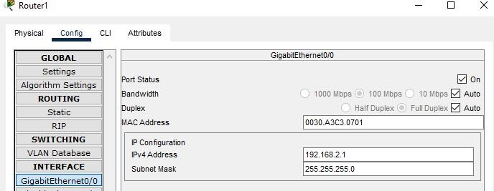

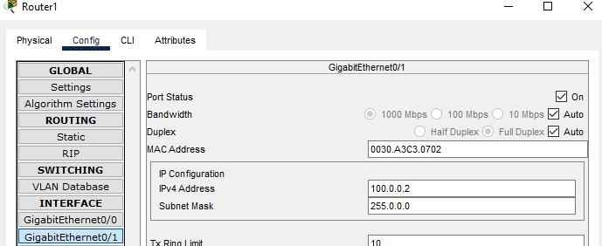

**Step 5: Static NAT Configurations**

Router 0:

Static NAT configuration steps:

1. **Define IP address mapping :**

In static NAT, we have to map each inside local IP address with inside global IP address. Following command in Screen Shot is used for mapping.

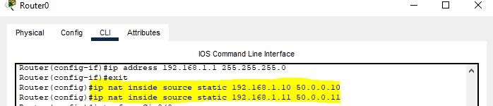

1. **Define inside local interface:**

In the second step we have to define which interface is connected with the local network. Following command will define interface Gig0/0 as inside local.

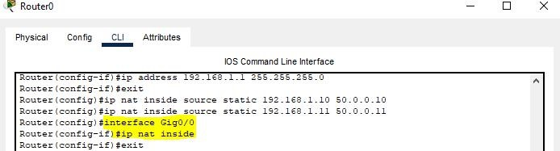

1. **Define inside global interface:**

In the third step we have to define which interface is connected with the global network. Following command will define interface Gig0/1 as inside global.

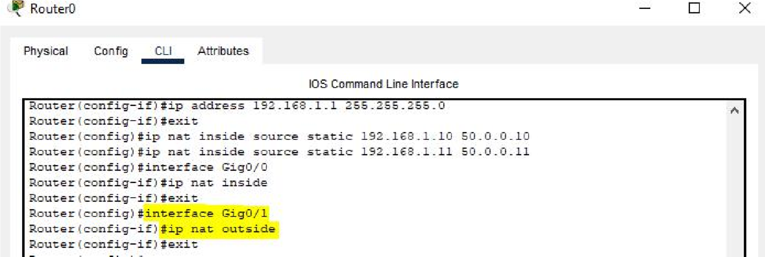

Router 1

We will repeat the same three steps for this router:

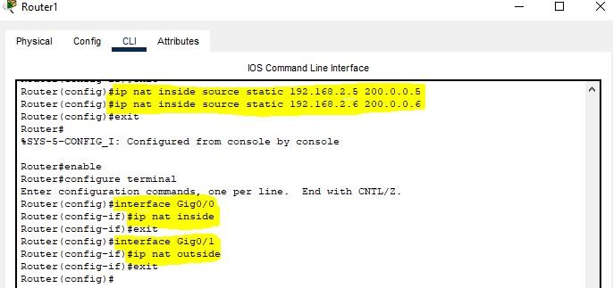

# Testing Static NAT Configuration:

To test this setup click Laptop 1 and Desktop and click Command Prompt and Run ping 200.0.0.5 command.

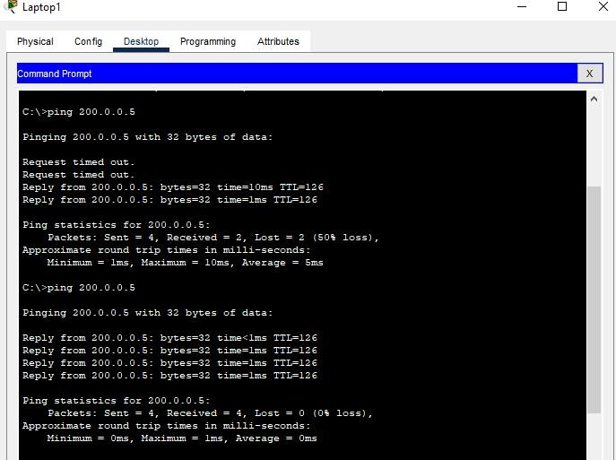

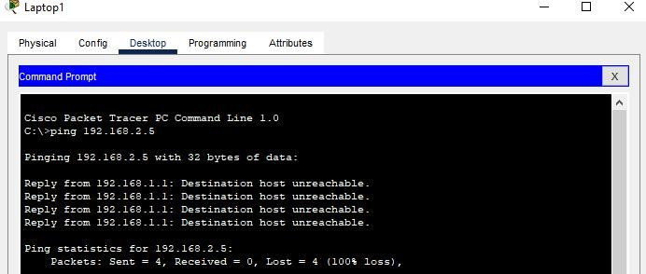

**Next we create a file and upload it on flex**

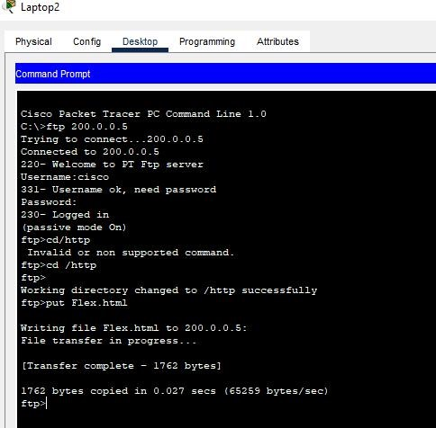

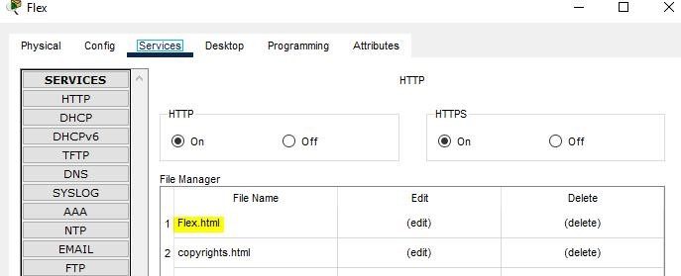

For testing Click Laptop1, click Desktop, then click Web Browser and access 200.0.0.5.

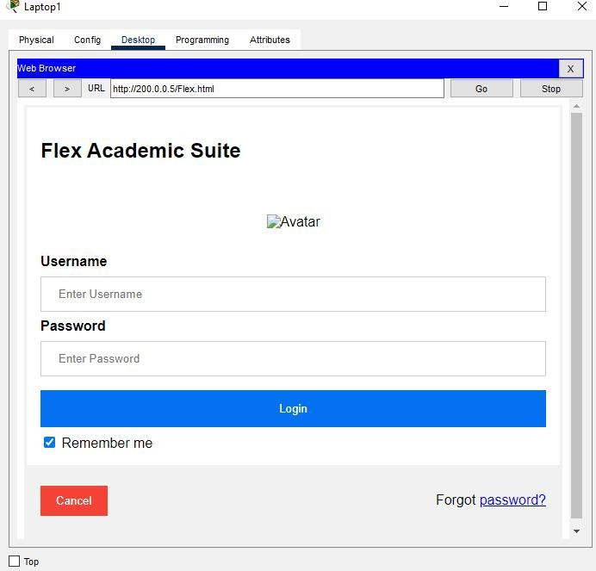

Done